Emotional Wellbeing Update

HELPING YOURSELVES, HELPING EACH OTHER AND HELPING OUR FAMILIES
The emotional wellbeing and mental health of everyone matters - now more than ever with the emotional and mental impact of the current lockdown undoubtedly
taking its toll. Providing support to parents and students is a key focus.

Please see below a variety of services and support that are accessible to you:

School Nurse ‘Virtual Drop in’ – Tuesdays 10am -12pm
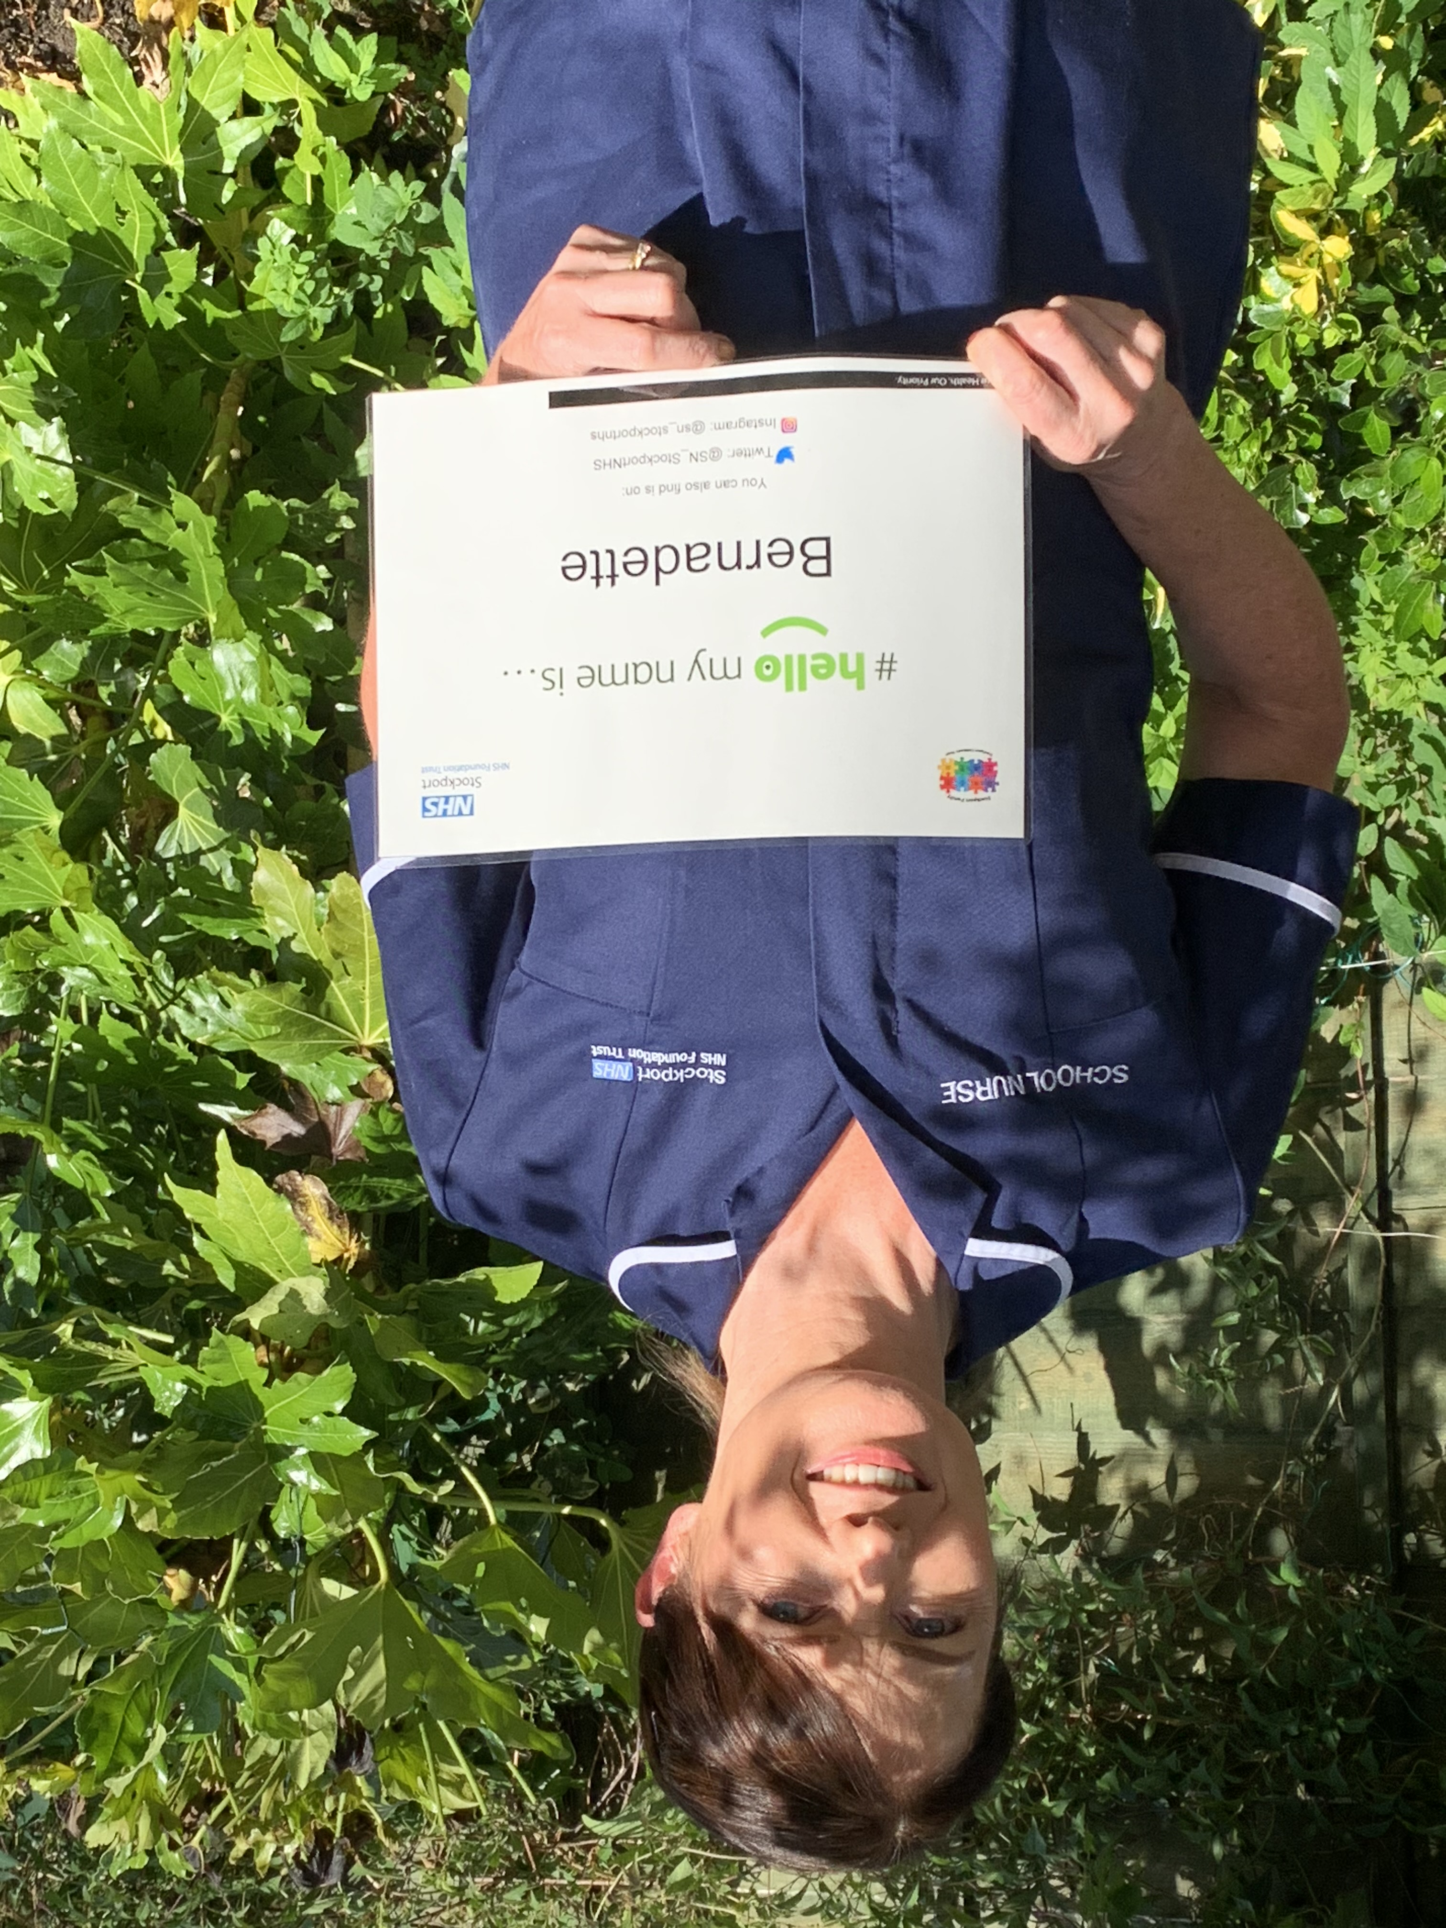Our School Nurse Bernie Brown is offering advice and support around many issues i.e. healthy eating, weight management, continence issues, emotional support, support around ongoing health conditions, bereavement, head lice etc. Parents and children
are encouraged to ring or email her to have a chat about anything and she will try and signpost them for support if necessary.
Contact details:
Mobile: 07808202063
Email: Bernadette.brown@nhs.net

Young Minds Helpline
Our Parents Helpline is available to offer advice to parents and carers worried about a child or young person under 25.You may have questions about a child’s behaviour, emotional wellbeing, or mental health condition. You may have a child who’s already been admitted to CAMHS and have questions about their treatment or want to know what to say to your GP when you visit them. Our trained advisers are here to give you help and advice, whatever the question.

Call the Parents Helpline on 0808 802 5544Call us for free Mon-Fri from 9.30am to 4pm – available in England, Scotland, Wales and Northern Ireland. https://youngminds.org.uk/Calls may be recorded for monitoring or training purposes.

Parental Engagement Network

Many people are dealing with anxieties that we are not prepared for. If you are looking

for support for your families or even yourselves, here are some links www.winstonswish.org/coronavirus/.

MIND www.mind.org.uk/information-support/for-children-and-young-people/coronavirus/managing-feelings-about-changes-to-lockdown/
Information for young people who are struggling with their feelings about lockdown changing, and want to know how to cope and adjust.

Emotional Wellbeing Hub

Provides Information, advice, and guidance for anyone up to the age of25 for emotional wellbeing and mental health concerns.

Access to the Emotional Wellbeing Hub is through the Multi-Agency Safeguarding and Support Hub (MASSH), 0161 217 6028.

Open 8.30am to 5pm Monday to Thursday and 8.30am to 4.30pm on Friday.

Big White Wall www.bigwhitewall.com
Provides 24/7 anonymous support via a digital emotional wellbeing and mental health service.
It is available for anyone over the age of 16 living in Stockport.
It offers peer support alongside a range of helpful tools and resources and is supported by trained clinicians.
To register you just need your Stockport postcode.

SHOUT www.giveusashout.org/get-help
SHOUT is a 24/7 UK crisis text service available for times when people feel they need immediate support.
By texting ‘SHOUT’ to 85258 a ‘texter’ will be put in touch with a trained Crisis Volunteer (CV) who will chat to them using trained techniques via text. The service is designed to help individuals to think more clearly and to take their next step to feeling better.
To get help or find out more about how SHOUT.

Kooth www.kooth.com
All children and young people in Greater Manchester can now access free online counselling and emotional well-being support.
Kooth online counselling and emotional wellbeing platform is available to any young person who may be struggling with their mental health – and particularly during the COVID-19 outbreak.
Kooth is for young people aged 11-18 and offers a variety of resources, including: A live chat function that allows young people to contact a qualified counsellor, chat forums with other young people, crisis information and Self-help resources.

42ND STREET www.42ndstreet.org.uk
One-to-one counselling therapy, psycho-social support and advocacy therapeutic
issue-based, identity-based groups and peer support projects, creative projects and
approaches to wellbeing and mental health via The Horsfall Residentials.
42nd Street takes referrals from young people themselves and from parents, carers
and professionals.

