AQA ENGLISH LANGUAGE PAPER 2:
Writers’ Viewpoints and Perspectives

NURSING: THEN AND NOW

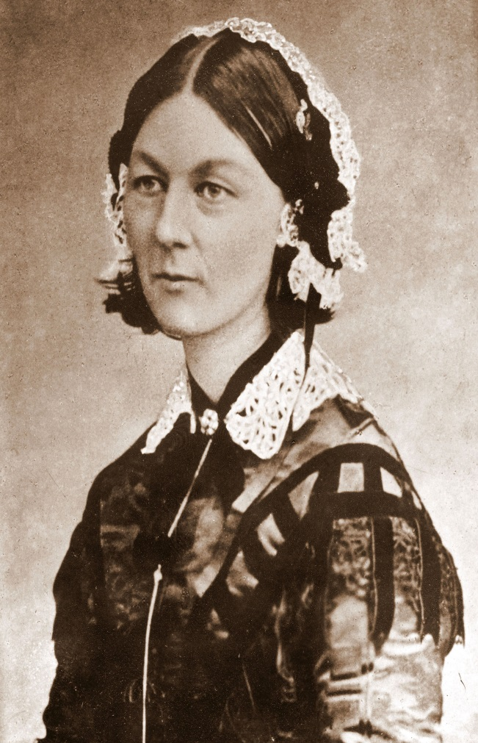

Two non-fiction texts based on
The same theme or topic

SOURCE A:  Florence Nightingale was a nurse during the Crimean war, when Britain and France went to war with Russia for two years in 1854.  In this extract, she describes her role nursing wounded soldiers:  A message came to me to prepare for 510 wounded on our side of the Hospital who were arriving from the dreadful affair of the 5th November from Balaklava, in which battle were 1763 wounded and 442 killed, besides 96 officers wounded and 38 killed. I always expected to end my Days as Hospital Matron, but I never expected to be Barrack Mistress. We had but half an hour’s notice before they began landing the wounded. Between one and 9 o’clock we had the mattresses stuffed, sewn up, laid down—alas! Only upon matting on the floor—the men washed and put to bed, and all their wounds dressed. I wish I had time. I would write you a letter dear to a surgeon’s heart. I am as good as a Medical Times! But oh! you Gentlemen of England who sit at home in all the well-earned satisfaction of your successful cases, can have little idea from reading the newspapers of the horror and misery in a Military Hospital of operating upon these dying, exhausted men. A London Hospital is like a Garden of Flowers compared to it.  We have our Quarters in one Tower of the Barrack, and all this fresh influx has been laid down between us and the Main Guard, in two Corridors, with a line of beds down each side, just room for one person to pass between, and four wards. Yet in the midst of this appalling horror (we are steeped up to our necks in blood) there is some good, and I can truly say, like St. Peter: “It is good for us to be here”—though I doubt that if St. Peter had been here, he would have said so. As I went my night-rounds among the newly wounded that first night, there was not one murmur, not one groan, the strictest discipline—the most absolute silence and quiet prevailed—only the steps of the Sentry—and I heard one man say: “I was dreaming of my friends at Home,” and another said, “I was thinking of them.” These poor fellows bear pain and mutilation with an unshrinking heroism which is really superhuman, and die, or are cut up without a complaint.  The wounded are now lying up to our very door, and we are landing 540 more from the Andes. I  take rank in the Army as Brigadier General, because 40 British females, whom I have with me, are  more difficult to manage than 4000 men. Let no lady come out here who is not used to fatigue and privation. Every ten minutes an Orderly runs, and we have to go and cram lint into the wound till a Surgeon can be sent for, and stop the Bleeding as well as we can. In all our corridor, I think we have not an average of three Limbs per man. And there are two Ships more “loading” at the Crimea with wounded—(this is our Phraseology). Then come the operations, and a melancholy, not an encouraging List is this. They are all performed in the wards—no time to move them; one poor fellow exhausted with hæmorrhage, has his leg amputated as a last hope, and dies ten minutes after the Surgeon has left him. Almost before the breath has left his body it is sewn up in its blanket, and carried away and buried the same day. We have no room for Corpses in the Wards. The Surgeons pass on to the next, an excision of the shoulder-joint, beautifully performed and going on well. Ball lodged just in the head of the joint and fracture starred all round. The next poor fellow has two Stumps for arms, and the next has lost an arm and a leg. As for the Balls they go in where they like and come out where they like and do as much harm as they can in passing. | 5  10  15  20  25  30  35

SOURCE B: Article taken from www.nursingtimes.net, May 7th 2014  The majority of NHS nurses feel underpaid, overworked and undervalued, according to a survey carried out jointly by Nursing Times and ITV.  More than eight of 10 nurses said they did not have enough time to give patients adequate care and a quarter believed they had put a patient’s life at risk because they were too busy or overworked. Staff shortages and too much paperwork were the most common factors stopping nurses from doing their job properly, they said.  The survey results were due to be featured this week in ITV’s breakfast programme Good Morning Britain, as part of a special edition on nursing. The findings are a stark reminder of the everyday pressures faced by frontline nursing staff, and their view that staffing remains the key factor in ensuring patient safety.  Despite an increasing recognition by many hospital trusts that they need to recruit more nurses, the findings suggest there is still a long way to go. This was further confirmed last week when persistent staff shortages were cited as a major factor for Heatherwood and Wexham Park Hospitals Foundation Trust being placed in “special measures” by healthcare regulators.  Around two-thirds of respondents, 66%, said they worried about the level of care that their ward, hospital or clinic could give to patients outside normal working hours. A similar percentage said their ward, hospital or clinic could not function at night, weekends or Bank Holidays without using agency staff. A massive 96% of respondents said there is too much paperwork in the NHS, in spite of ongoing efforts to reduce it, for example by improving technology, and it being a government priority that is often name-checked in ministerial speeches.  In addition, 76% of survey respondents said they did not feel valued by their manager and 86% said they did not get paid enough money for the job they do. A possible concern is that a significant chunk of respondents lacked confidence in their own work environment. Asked whether they would be happy to be a patient in the ward, hospital or clinic where they worked, 57% “yes” but 43% said “no”. Meanwhile, when asked whether they would encourage their own child to go into nursing, based on their experience, 73% of participants said “no”, while only 27% answered “yes”.  Although, the survey results highlighted the struggles faced by nurses, respondents remained positive about their motivation. One nurse said: “My job is great and I love it, when I am given the opportunity to do it well,” while another stated: “Although my responses are negative, I love my job.” A further respondent said: “Despite all the pressures, the public should understand that as nurses we do try our best.” | 5  10  15  20  25

Q1: Read lines 1 to 11 of Source A.
Choose four statements below which are TRUE. [4 marks]

- 510 wounded soldiers arrived at the same time

- 442 were killed in the Battle of Balaklava

- There were not enough bandages to dress wounds

- The nurses had only 30 minutes to prepare

- The men were washed before being put to bed

- 176 were wounded in the Battle of Balaklava

- Florence Nightingale is a Hospital Matron

Q2: Refer to Source A and Source B. Write a summary of the differences
in the writers’ attitudes to nursing.
[8 Marks]

Q3: Refer to Source B.
How does the writer use language to convey their opinions of the
state of the NHS.
[12 Marks]

Q4: Refer to Source A and Source B.

Compare how the writers convey their attitudes to nursing.

In your answer, you should:

- compare their attitudes
- compare the methods they use to convey their attitudes
- support your ideas with quotations from both texts
[16 Marks]

Section B: Writing

You are advised to spend about 45 minutes on this section.
Write in full sentences.
You are reminded of the need to plan your answer.
You should leave enough time to check your work at the end.

Q5

“Nurses deserve much better pay and working conditions in recognition of the vital
work they do in saving lives, day after day.”

Write a letter to your local MP in which you explain your views on this statement.

(24 marks for content and organisation
16 marks for technical accuracy)

[40 marks]

