Section B Writing

You are advised to spend about 45 minutes on this section.
You are reminded of the need to plan your answer.
You should write in full sentences.
You should leave enough time to check your work at the end.

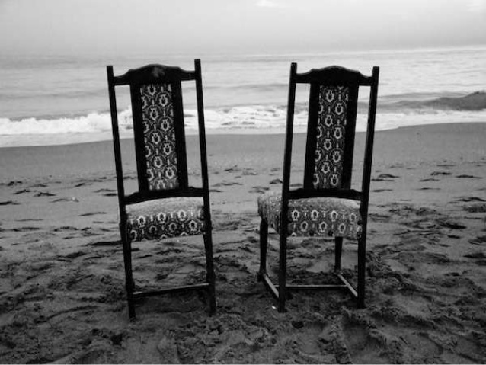

Write a description suggested by this picture

Or

Write the opening part of a story about a memory.

24 marks for content and organisation
16 marks for technical accuracy
[40 marks]

